**Test Plan:**

Here’s how I tested the program to make sure it works properly:

First of all, I checked if the menu loaded or not.

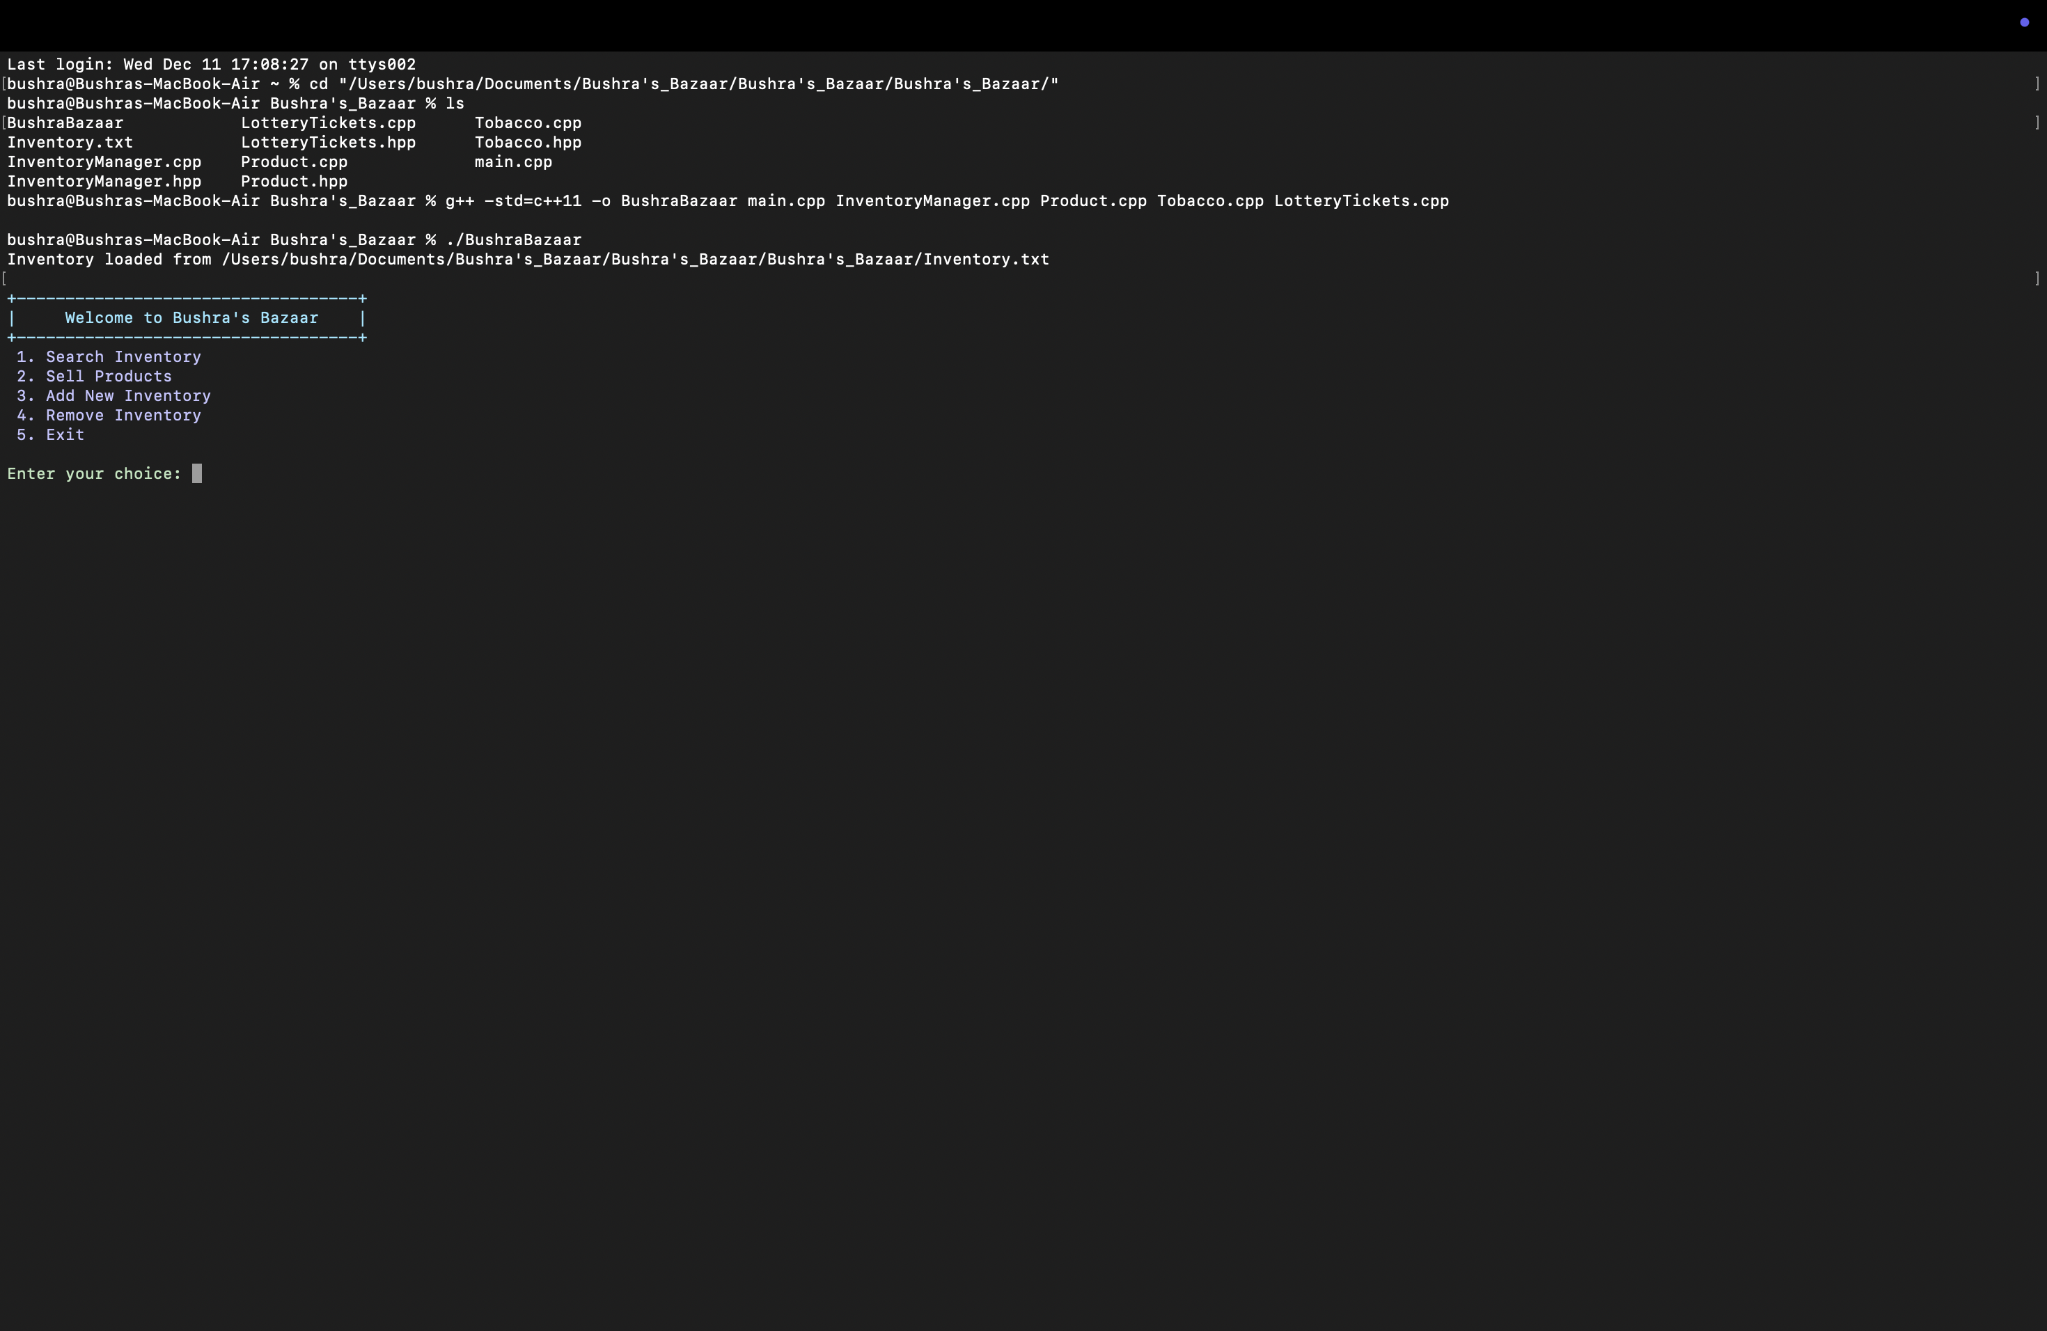

1. Test the Menu Options:

* Option 1: Search Inventory:
* Tested searching by category (like "Snacks") to see the correct results.

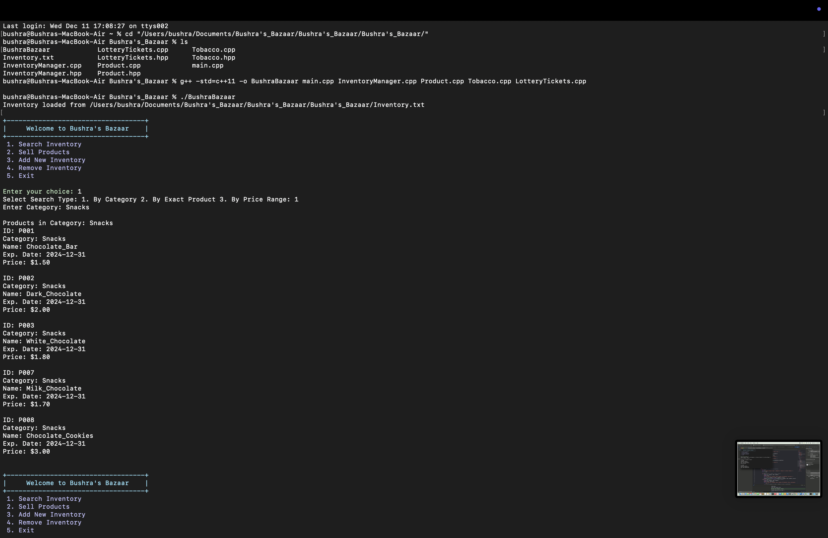

* Searched for specific products using their name or ID to ensure they showed up correctly.

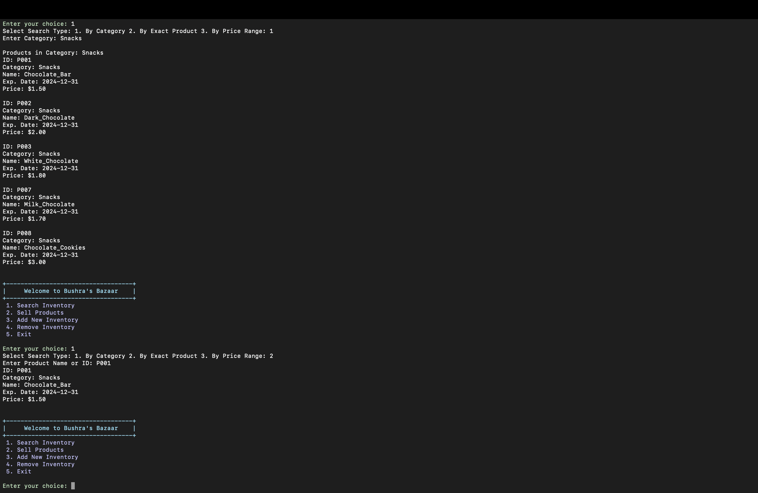

* Tried searching by price range and confirmed that only matching products appeared.

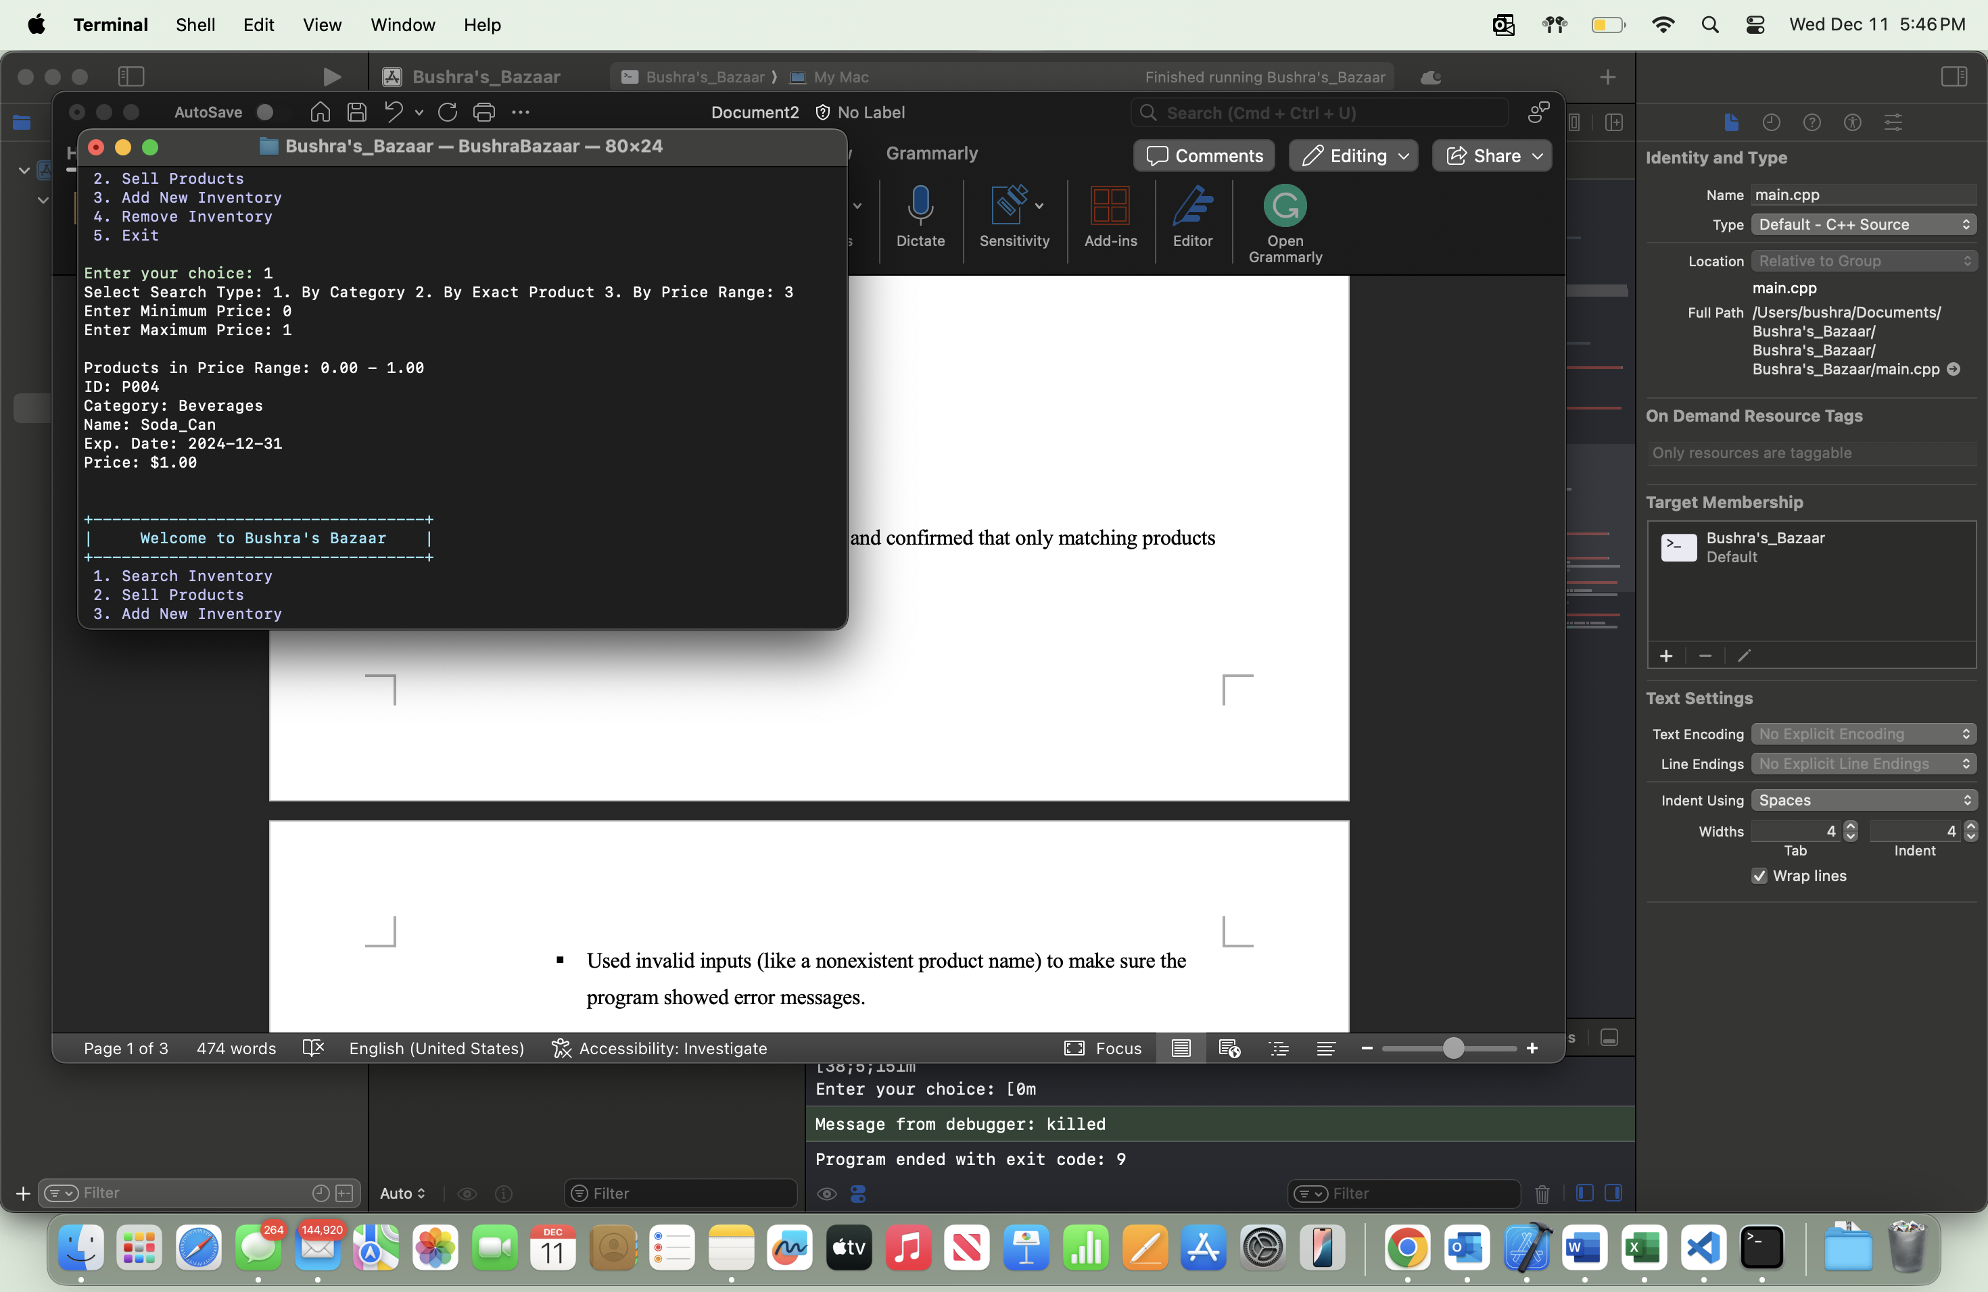

* Used invalid inputs (like a nonexistent product name) to make sure the program showed error messages.

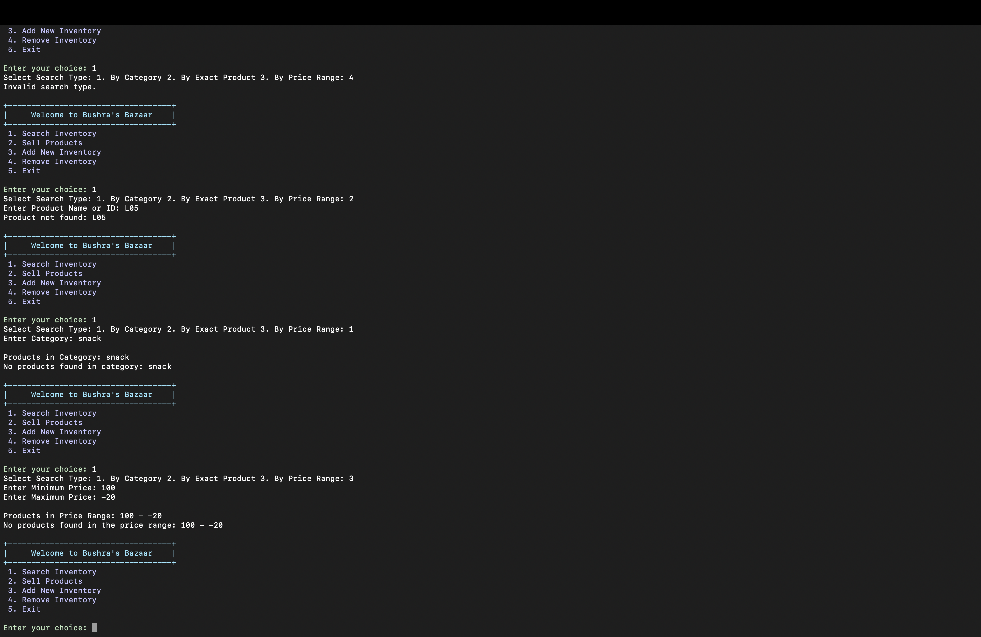

* Option 2: Sell Products:
* Sold a product by entering a valid ID and confirmed it was removed from the inventory.

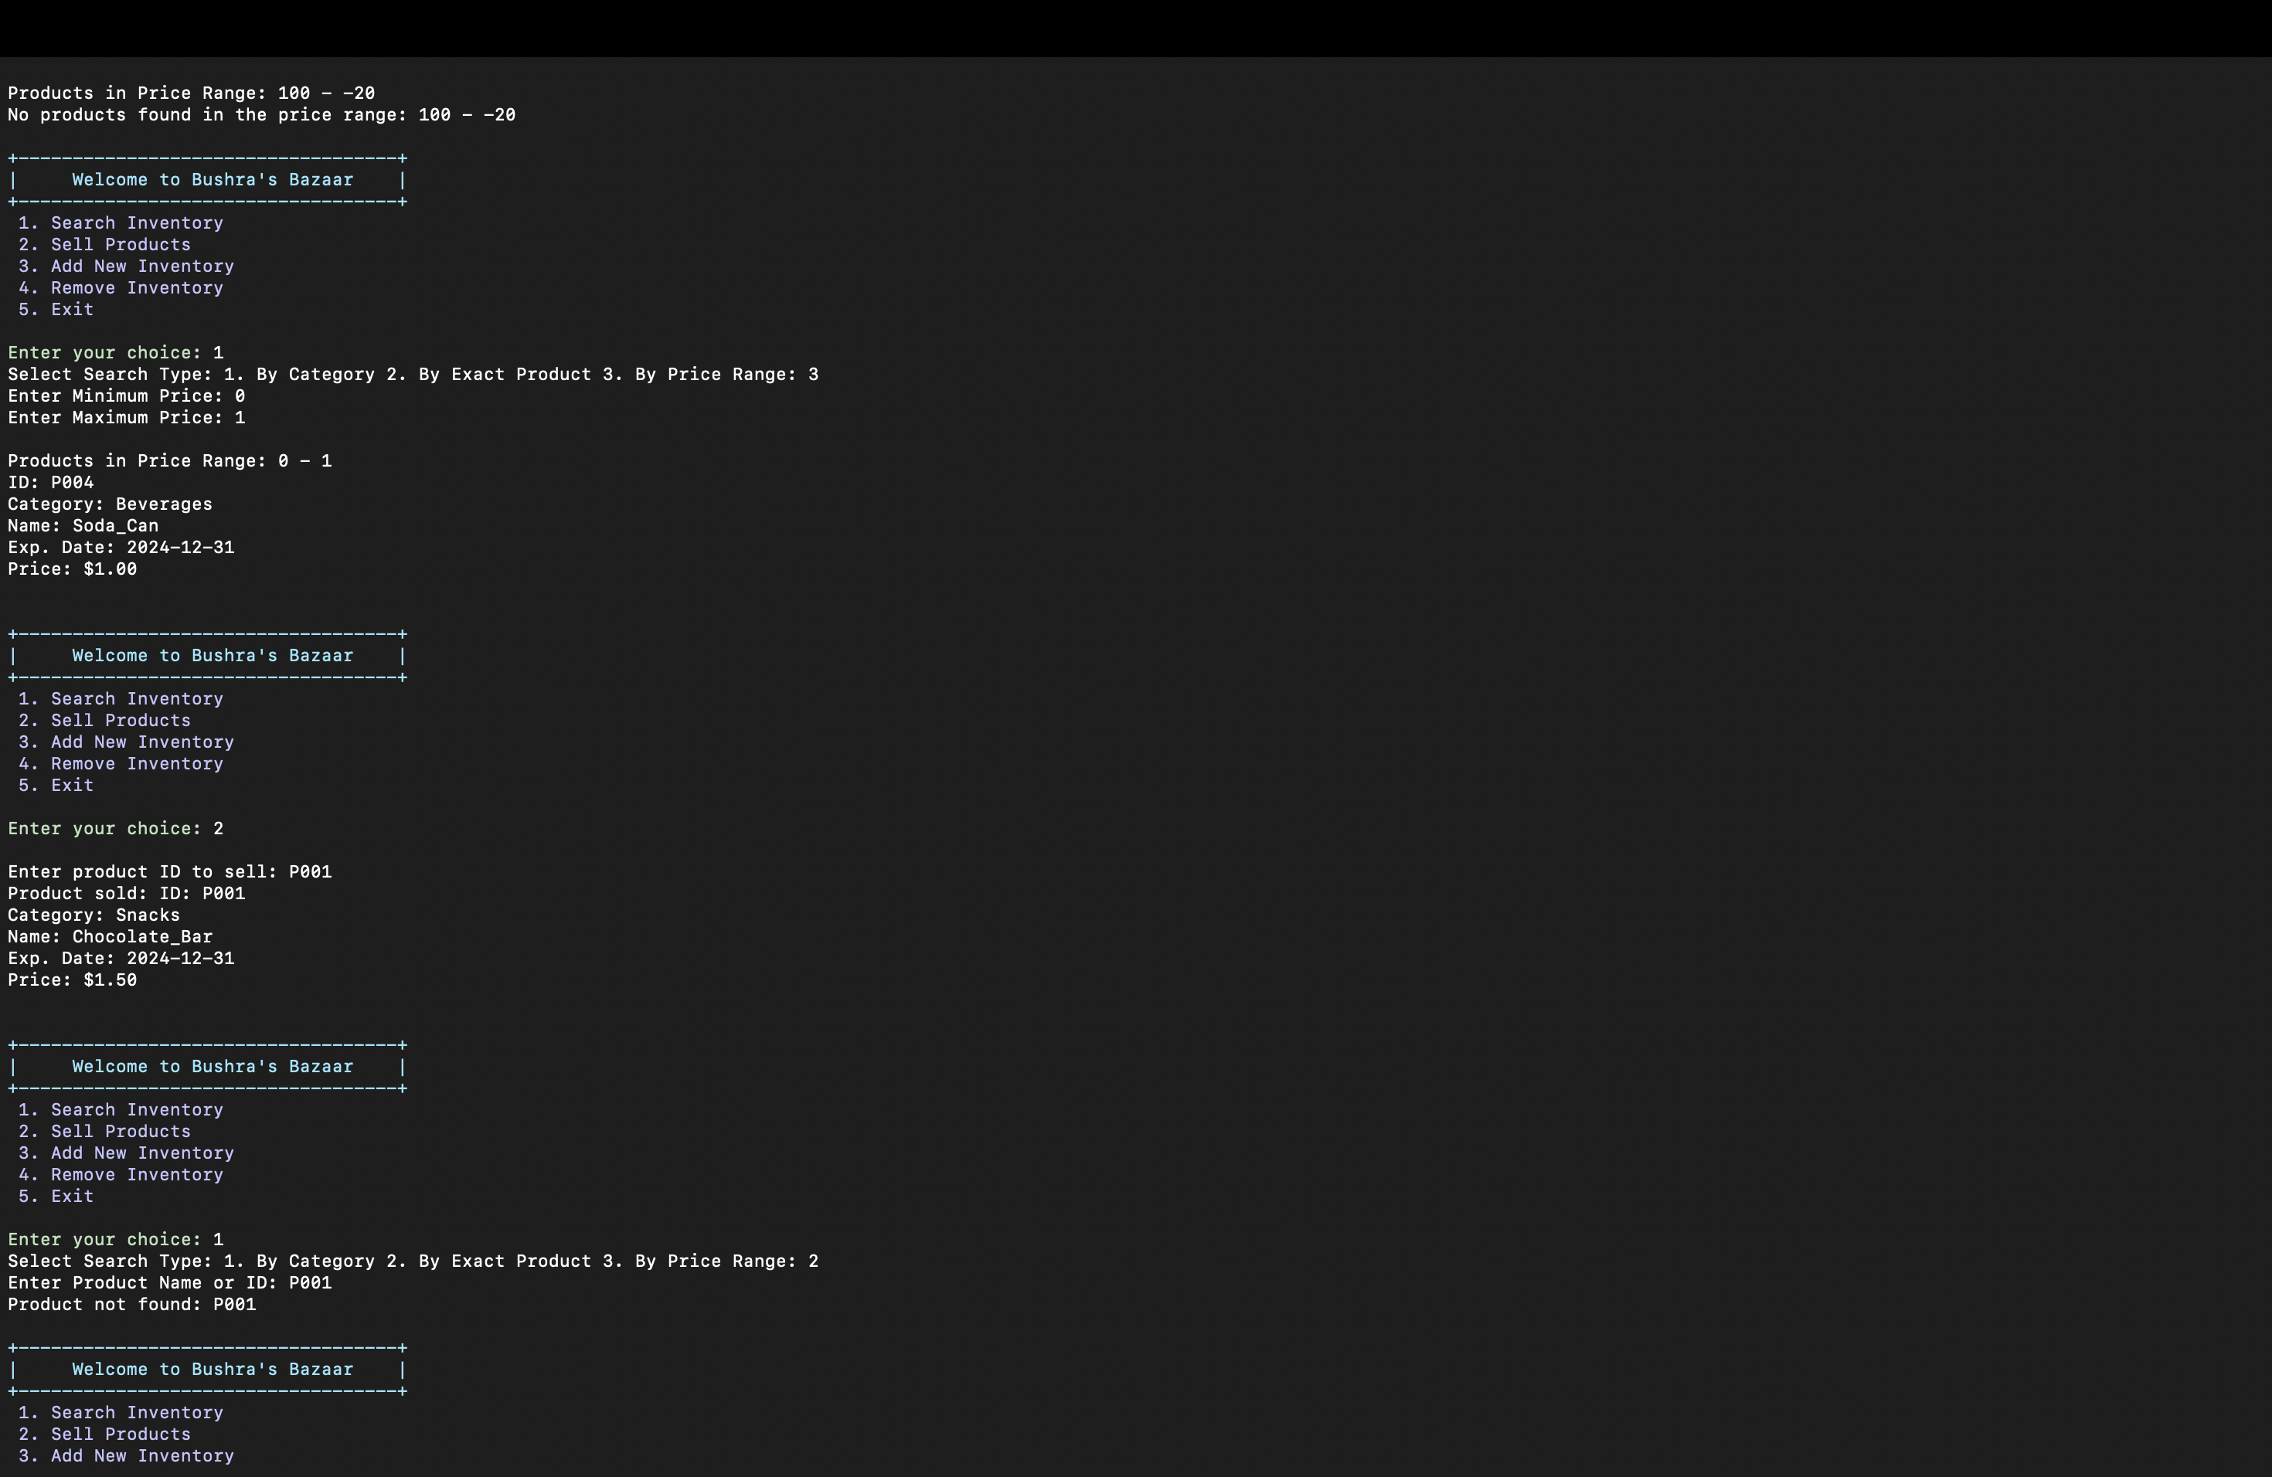

* Tried selling a product that doesn’t exist to ensure the program handled it with an error message.

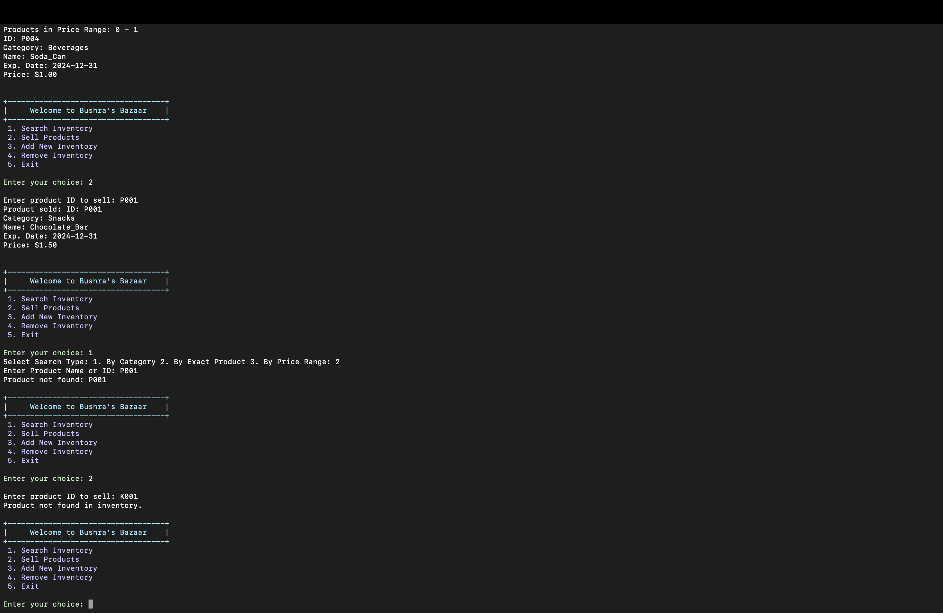

* Option 3: Add New Inventory:
* Added different types of products (like regular items, tobacco, and lottery tickets) and checked if they were added correctly.

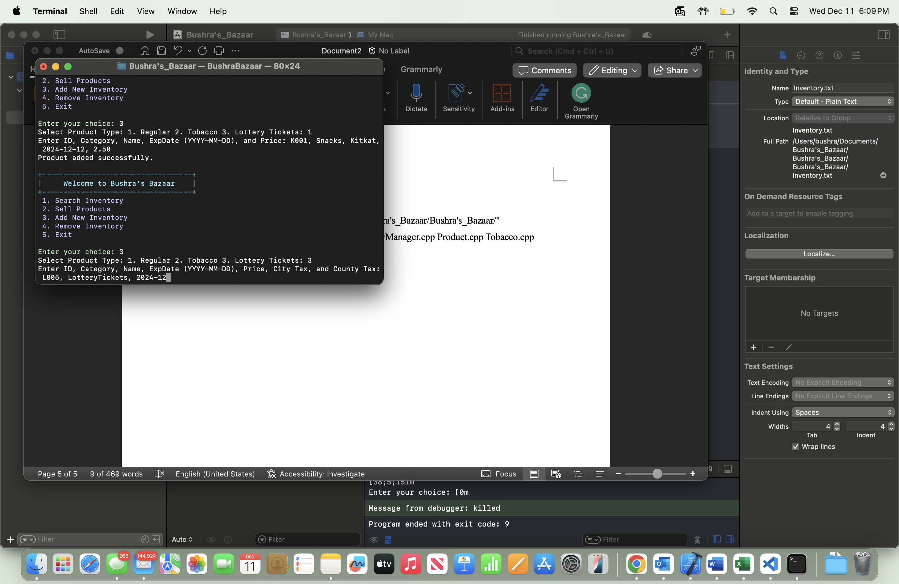

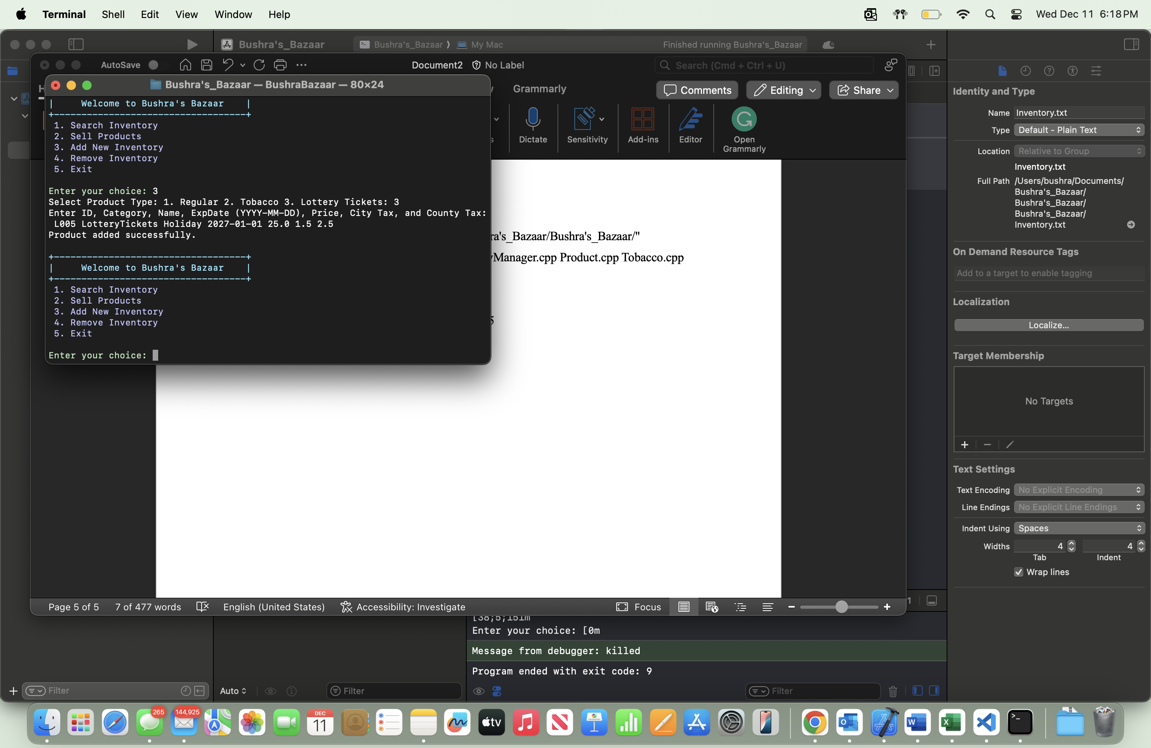

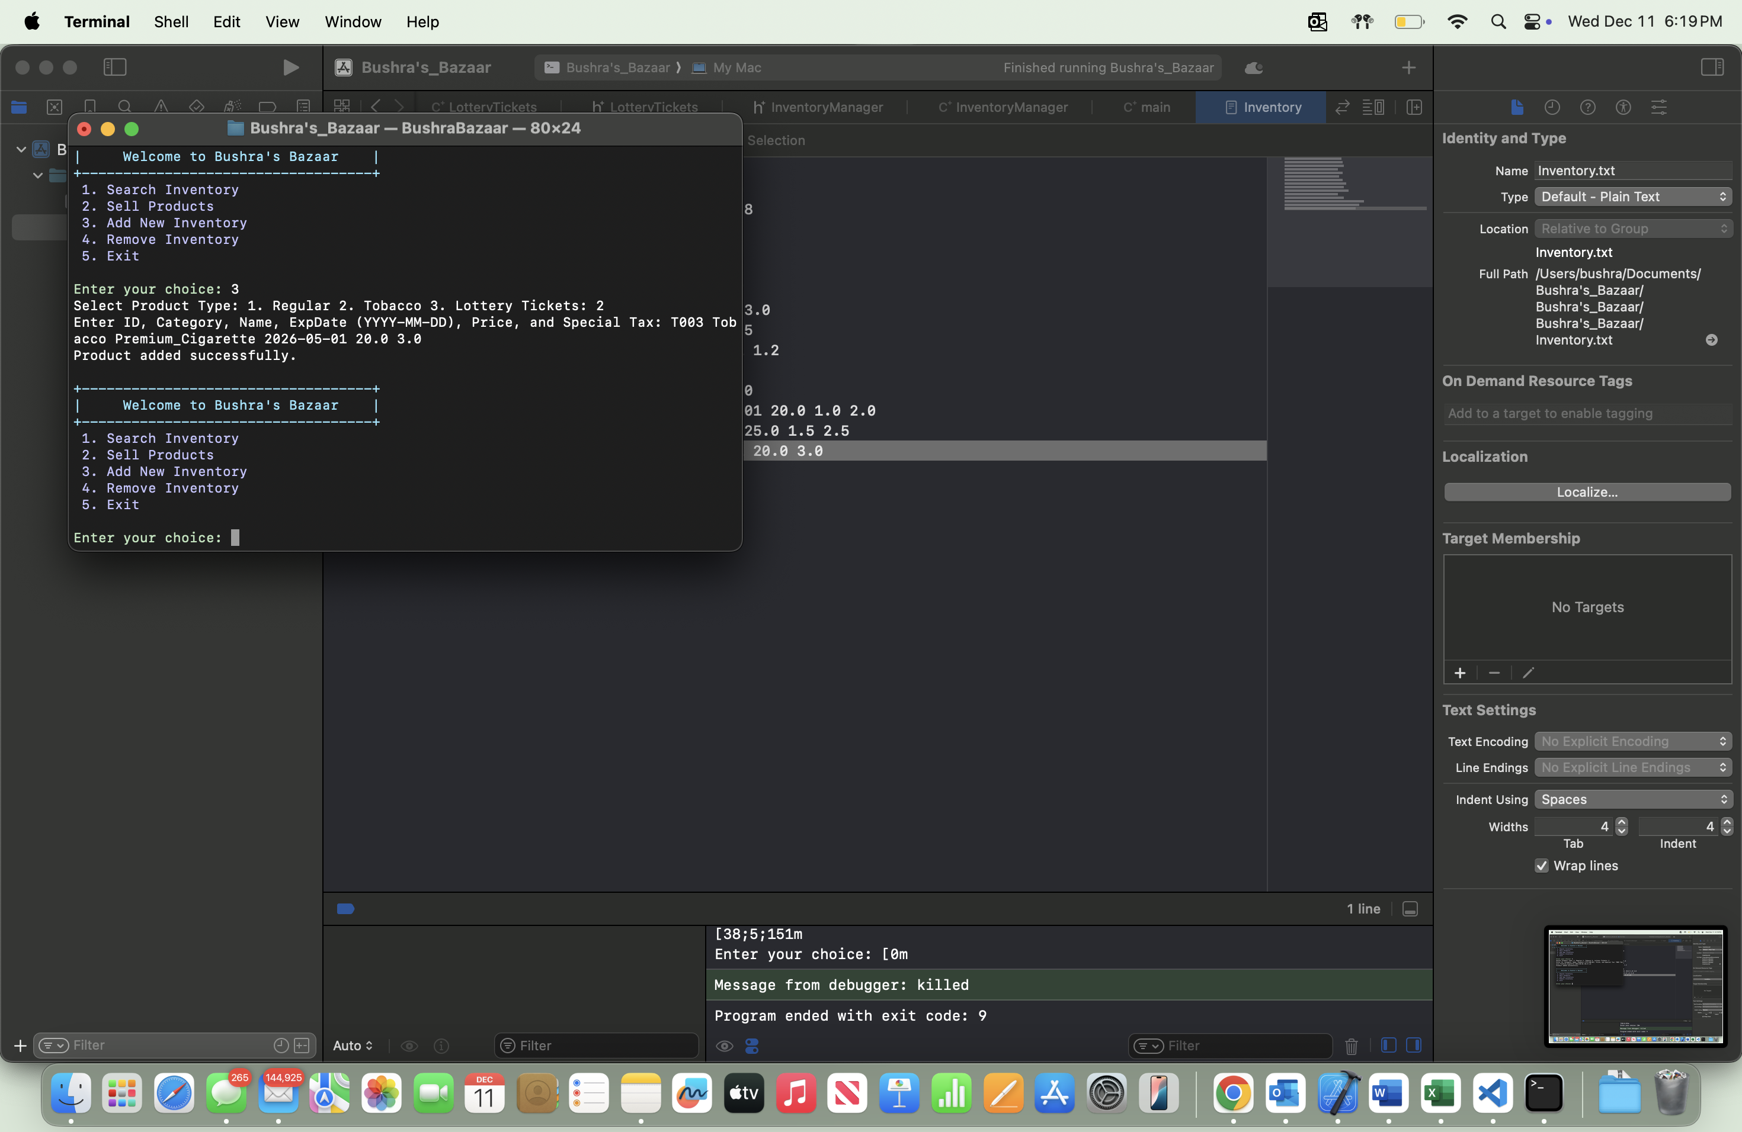

* Option 4: Remove Inventory:
* Removed a product by ID and confirmed it was deleted from the inventory.

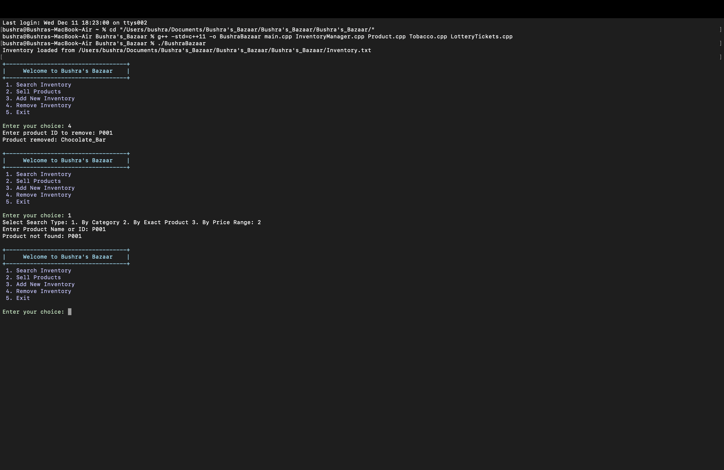

* Tried removing a nonexistent product and checked for the appropriate error message.

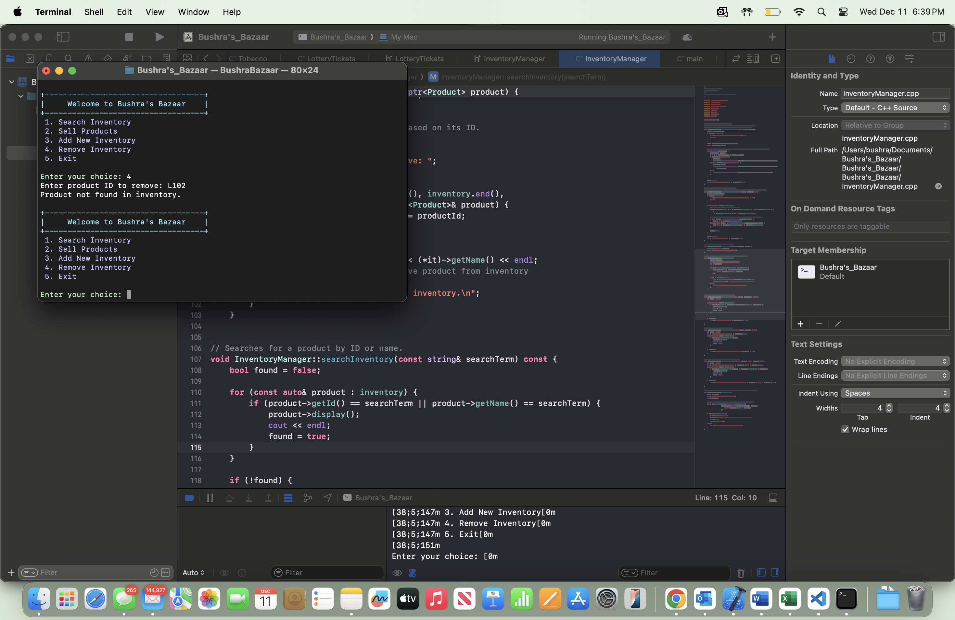

* Option 5: Exit:
* Exited the program

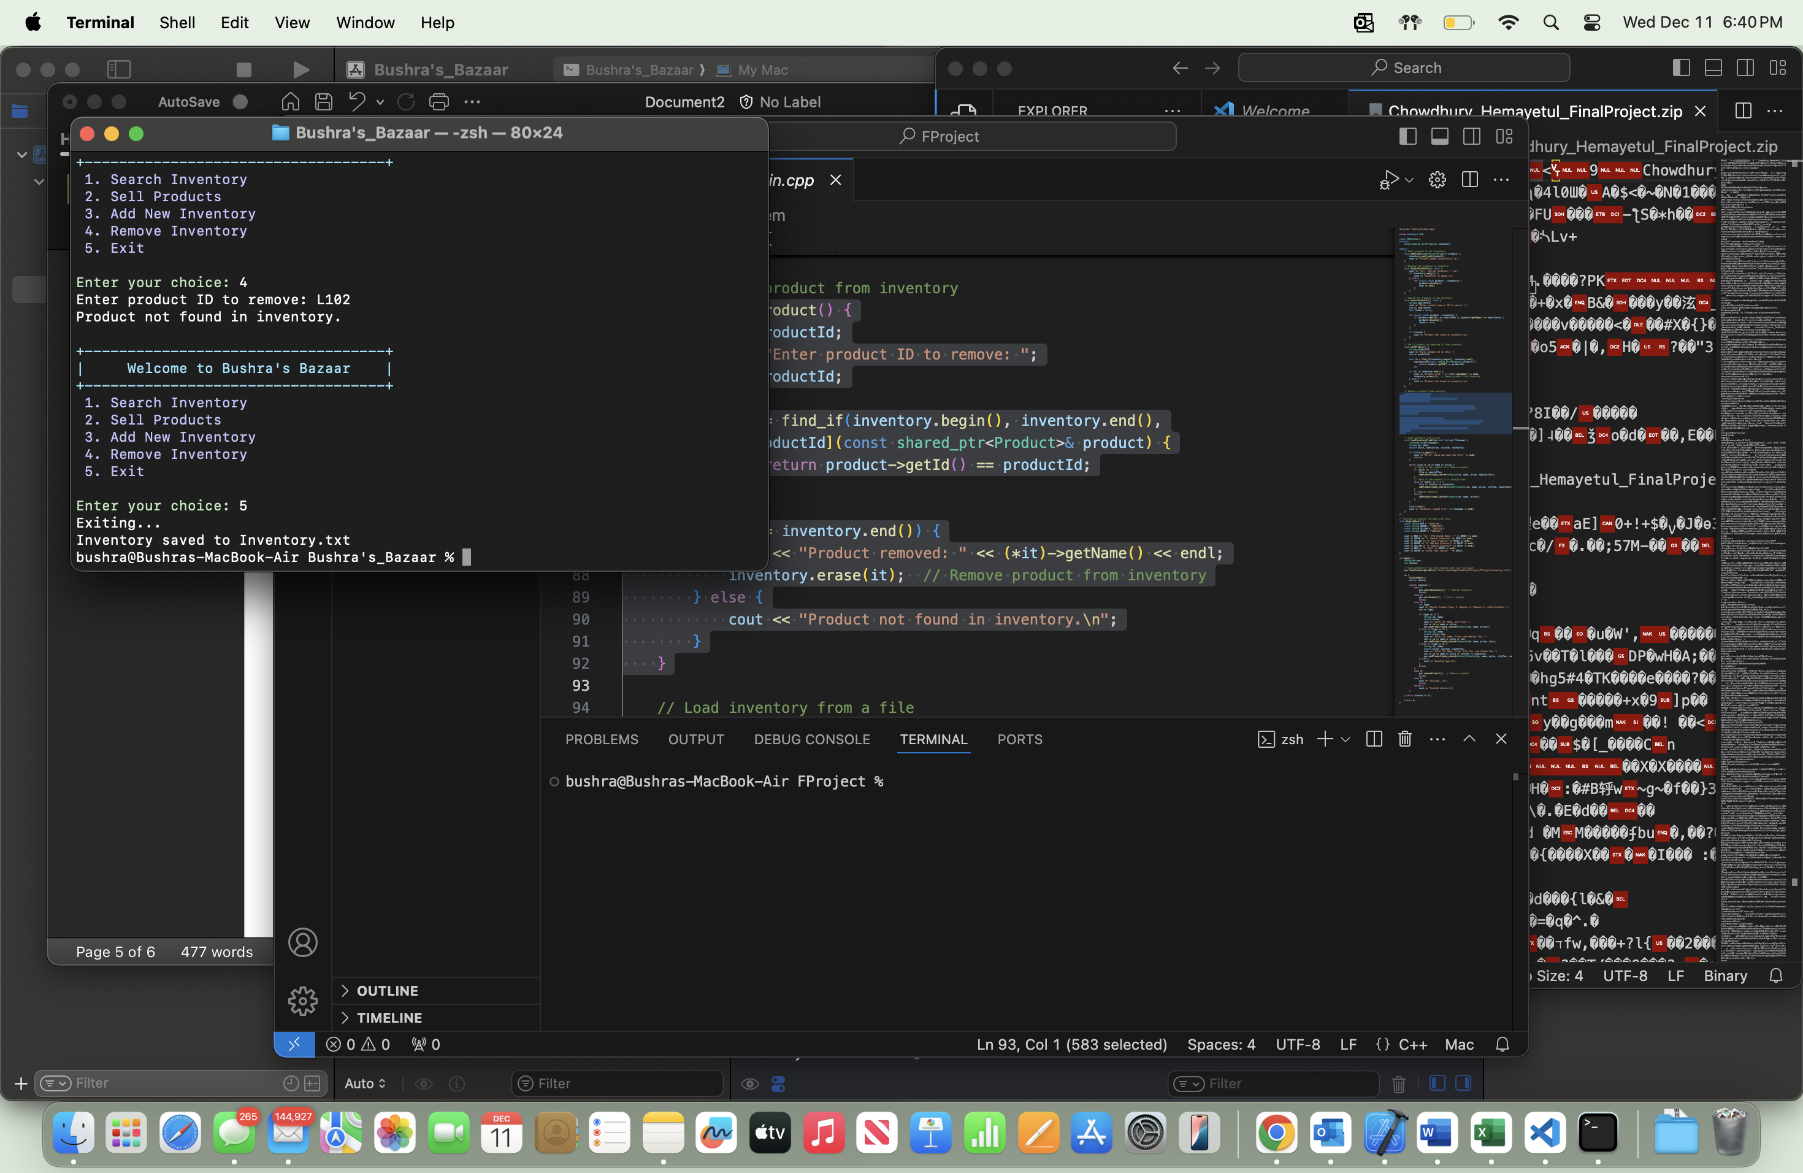

1. Check for Errors:
   * Entered wrong or invalid inputs (like negative prices or empty fields) and made sure the program handled them without crashing.

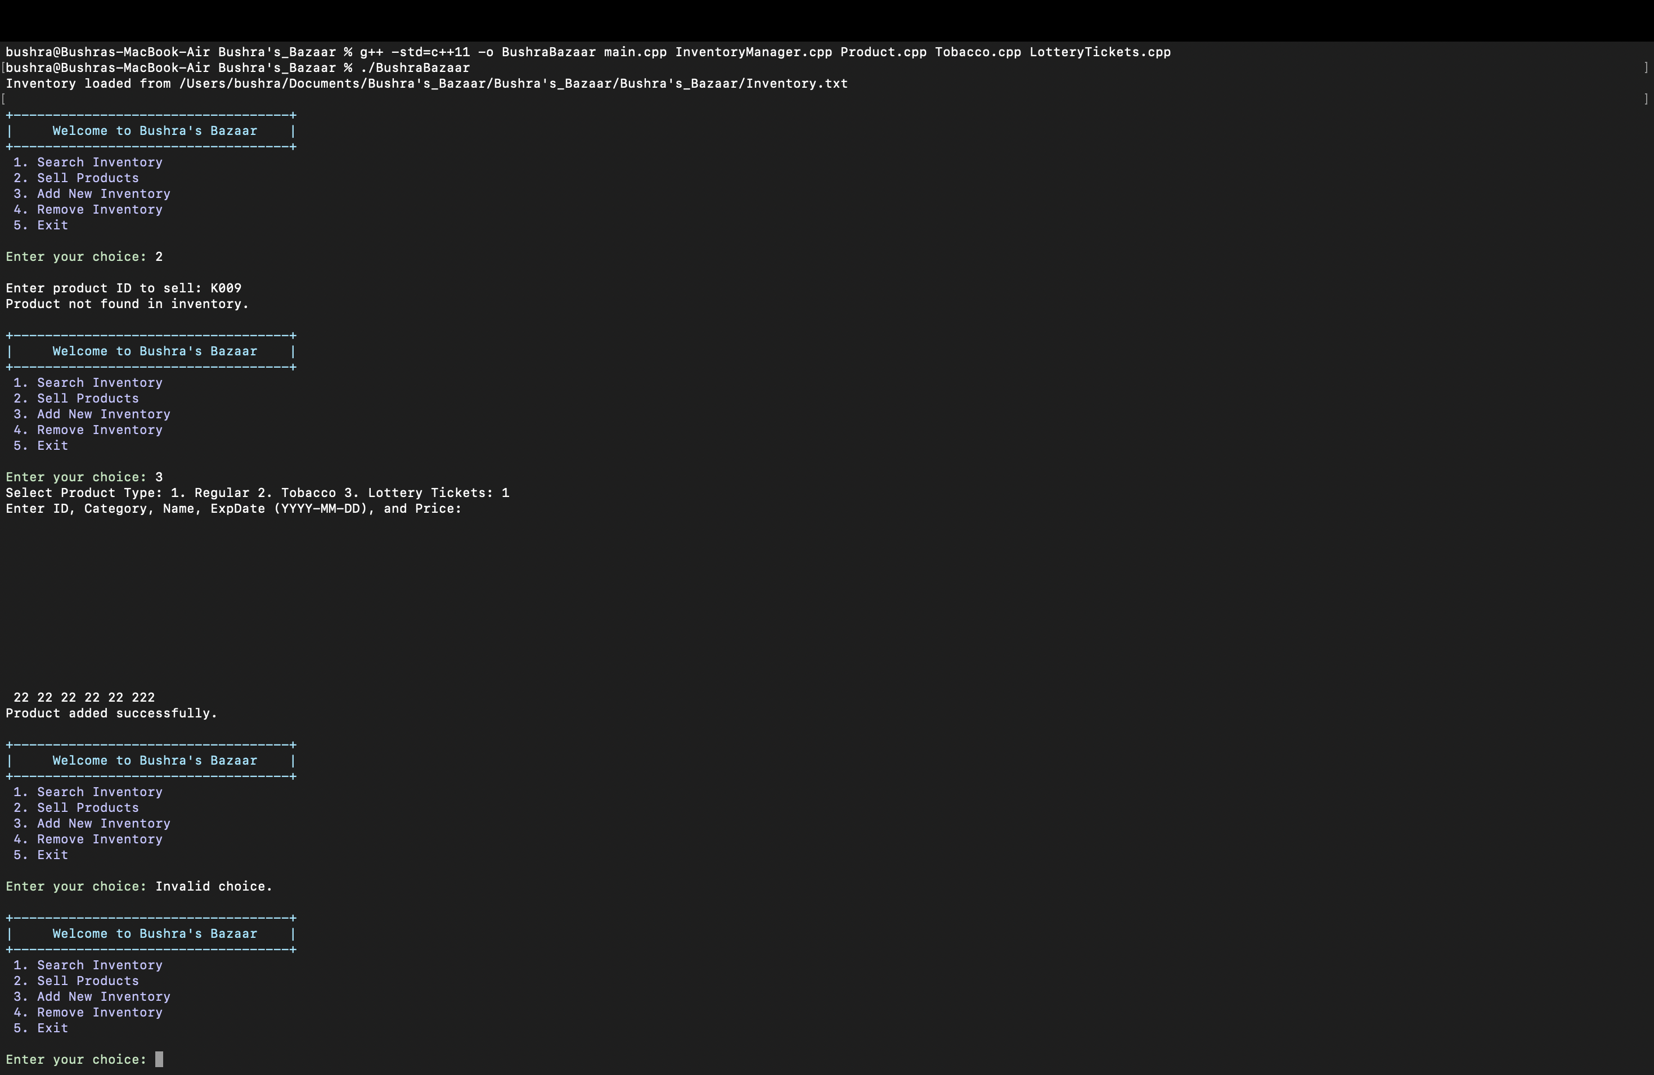

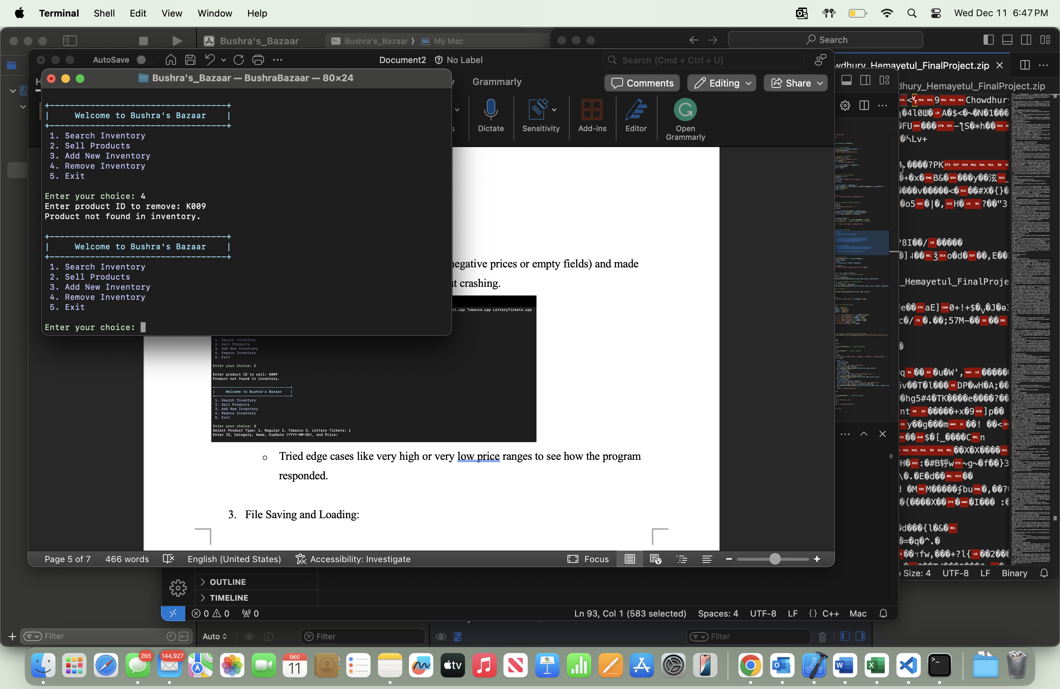

**Design Plan:**

This program is designed to manage the inventory in a simple and organized way:

* How It Works:
* Product Class: This is the base class for all products. It stores basic details like ID, name, category, and price.
* Tobacco and LotteryTickets Classes: These are special types of products that add extra details like taxes.
* InventoryManager Class: This handles everything related to the inventory, like adding, removing, selling, and saving products.
* Why It’s Simple:
* The program uses a vector to store all products, so it’s easy to add or remove items.
* The design is straightforward and easy to extend if more product types are needed later.
* What Makes It Good:
* It’s easy to use—just follow the menu options.
* The program handles errors gracefully, so it won’t crash if something goes wrong.
* It’s organized, making it simple to add new features if needed.

cd "/Users/bushra/Documents/Bushra's_Bazaar/Bushra's_Bazaar/Bushra's_Bazaar/"

g++ -std=c++11 -o BushraBazaar main.cpp InventoryManager.cpp Product.cpp Tobacco.cpp LotteryTickets.cpp

./BushraBazaar